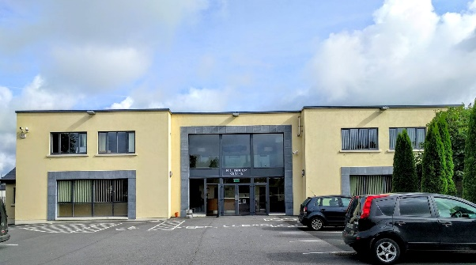
Millennium Centre
Name Plaque
Dear Friends and Supporters near and far,

As you will know the Millennium Centre has been upgraded over the past few years thanks to the generosity of you our friends and sponsors. Many of you have travelled and emigrated but you continue to support us in so many ways.

We are inviting you, your family, your friends and the wider community to help with our future planning by purchasing; a Name Plaque 6” x 4” (150 x 100 mm) for the sum of €100.
You will be registered as a lifetime member of the Millennium Sports and Social Club in return for your support. Your Plaque with your inscription will be displayed prominently in the Millennium Centre and highlighted appropriately.

You can pay in instalments - multiples of €10 and your plaque will be displayed when the full amount of €100 is paid. You can see the location and a sample Plaque at the centre or we can send you a photograph or video of samples. You will be purchasing a prominent and permanent fixture in the history of the Millennium Centre and we intend to regularly acknowledge our supporters via media sources to show our continued appreciation of that support.

The objective is to continue our preparations for further improvements in our community service at the Millennium Centre.

If you would like to help please fill out the form overleaf with your exact inscription in BLOCK CAPITALS keeping the number of letters as low as possible in 3 lines or less.

If you have any questions please give us a call on 061 351141.

Sample inscriptions:

IN LOVING MEMORY OF
JOSEPHINE RYAN
KNOCKBAWN
& FAMILY DUNVULLEN
JOSEPH & MARY
BLACKBURN
& FAMILY DUNVULLEN
Write your inscription (actual size) in the template below in BLOCK CAPITALS on 3 lines or less
Note: The printed layout may differ slightly from yours and is decided by the print design company to give the best appearance.

________________________________

________________________________

________________________________

Agreement

I ___________________________________________ agree that my Plaque will be displayed at the Millennium Centre, Caherconlish and I will pay the sum of €100 to the Centre.
I will pay in one amount of €_________
or I will pay in instalments of €_______________
Signed _____________________________ Date___________________
Thank you for your help and support which will ensure that this important community enterprise remains viable and continues to be of service to present and future generations.
Order received by the Millennium Centre
Date plaque ordered by Millennium Centre
Date Plaque installed and paid in full

